Axis Select CC

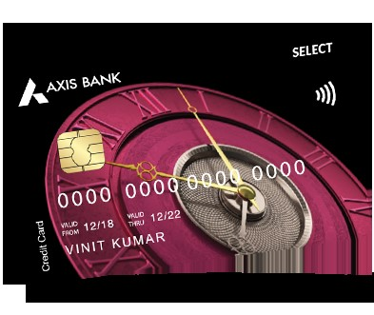

**Benefits of Axis Select Credit Card**

* Get 10,000 EDGE Reward points worth Rs. 2,000 on first card transaction within 30 days of card issuance. The rewards points will be credited into your EDGE rewards account within T+12 business days where “T” is the transaction date.
* Earn 10 Edge points on every Rs 200 spent, 2X rewards i.e. 20 Edge points on every 200 spent on retail shopping category (Dept Store, Grocery Store, Clothing and accessory stores, misc. apparel, and accessories store)
* **BigBasket:** Up to 20% Off on Orders over Rs 2000 upto Rs. 500 per month on BigBasket app or website. Offer applicable once per month. Per user. Discount code:  SELECTFEB24. Check : <https://www.bigbasket.com/axis-select/> for more details.
* **Swiggy:** Flat Rs.200 off on min cart value of Rs 500. Use code: AXIS200. Valid twice a month. Offer valid on transactions made through Axis Select credit card.
* **BookMyShow**: Buy 1 Get and get up to INR 300 off on the second ticket on BookMyShow. Offer applicable once per month per user on transactions made via Axis Select card.
* Get up to 12 Complimentary International Airport Lounge visits with Priority Pass Membership. Check details at <https://www.axisbank.com/docs/default-source/default-document-library/accounts/terms-and-conditions-select-credit-card.pdf> . Enjoy 2 complimentary domestic lounge visits per quarter. Check details : <https://www.axisbank.com/docs/default-source/default-document-library/axis-bank-airport-lounge-access-program.pdf> . Priority Pass will renew automatically upon meeting 3lakh spends in preceding card anniversary year,
* 5000 EDGE points on spending Rs 3 lakhs in a card anniversary year. Annual fee waiver on spending Rs. 6 Lakh in a card anniversary year. Spends threshold will exclude rent and wallet transactions. The merchant category code of rent is 6513 and wallet is 6540.
* Get 6 complimentary Golf rounds per year. Unlock 3 additional visits on spending Rs. 3 lakh annually. Visit: <https://www.extraordinaryweekends.com/> for more details. Click here for T&Cs: <https://www.axisbank.com/docs/default-source/default-document-library/golf_terms_and_conditions.pdf>
* Purchase Protection cover up to Rs. 1 lakh
* Cumulative cover up to USD 500 for following:
* Loss of travel documents
* Delay of check-in baggage
* Loss of check-in baggage.
* Click here for more details : <https://www.axisbank.com/docs/default-source/default-document-library/select_insurance_t-cs.pdf>
* Please Note: Existing Users of Axis Bank (Saving Account, Current Account, Loans or Credit Card) are not eligible for the offer

How to Apply for Axis Select Credit Card

* User Click on the CTA Button or the tracking link.
* He/ She click Login/Join Now and do OTP verification.
* Select Axis Select Credit Card and provide the required details
* His/her application will be submitted, and a confirmation SMS will be sent on approval of application
* User get his/her application status within 10 minutes.

Documents required for the Application

* PAN Card
* ID Proof
* Address Proof
* Bank Statement
* Income Proof

Eligibility Criteria

* Employment status: Salaried or Self-employed
* Salaried: Starting from 50000
* Self Employed: Starting from 60000
* Available across major cities in India
* Age: 21-60 years

Fees and List of all Charges

* Joining Fees: Rs 3000 +GST
* Annual Fees: Rs 3000 +GST
* Interest rate: 3.6% per month (52.86% per annum)
* Cash Withdrawal charges: 2.5% or Rs 500, whichever is higher
* Card Replacement charges: Nil

Important Information

* If user’s Card is disbursed, you will be eligible for commission.
* No Rewards if Application is Rejected